De-Tumbling Mode Satellite Model

Introduction
In this document, we set up the equations that describe the satellite system in de-tumbling mode. In this mode, the controller relies on the sensor input from the magnetometer, which is indicative of the satellite’s angular velocity. The controller’s output is a signal to the magnetorquers which results in a torque being exerted on the satellite. This signal is decided according to the B-dot control law [1].

Coordinate Systems
The two coordinate systems that are used in this document are the orbit coordinate system (OCS) and the body-fixed coordinate system. All vectors are described in the body-fixed coordinate system unless specified otherwise using a subscript.
The body-fixed coordinate system is a right-handed coordinate system defined by the three principal axes of the satellite.
The orbit coordinate system is defined as follows. The Z-axis (yaw) is the nadir vector. The X-axis (roll) is the perpendicular to the Z-axis in the orbit plane such that it makes an acute angle with the satellite’s velocity vector. The Y-axis (pitch) is the cross-product of the Z and X axes. The orbit coordinate system is illustrated in Figure 1.
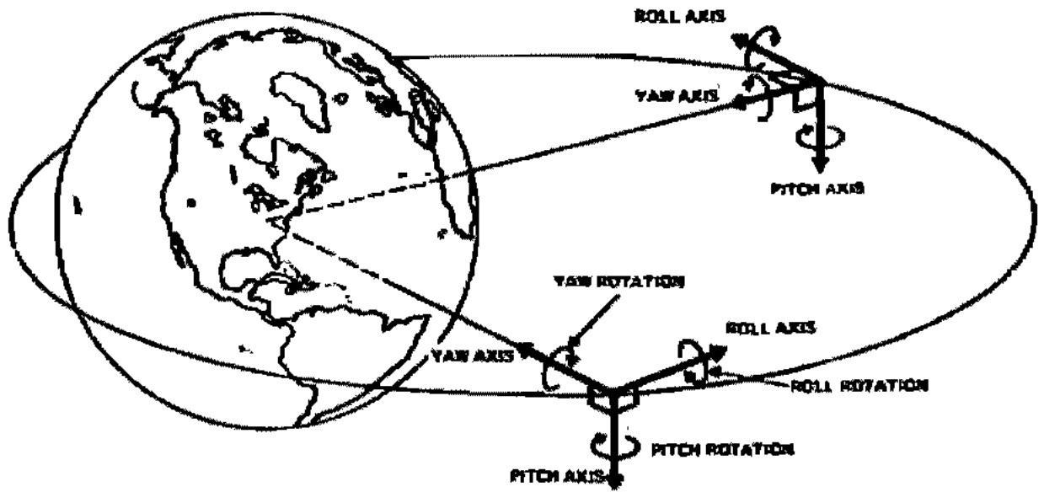
Fig. 1: Roll (X), pitch (Y) and yaw (Z) axes in the orbit coordinate system

Nomenclature
Orbit [Simulation Input]
: orbital angular velocity (2πnumber of revolutions around the Earth per second). This is a constant for a circular orbit.
Earth’s Magnetic Field [Simulation Input]
: The Earth’s magnetic field described in the orbit coordinate system. It varies with time due to the satellite’s change of position within its orbit (and the drift of the orbit plane, changes in orbit, etc.).
: The rate of the apparent change of the Earth’s magnetic field due to the satellite’s change of position within its orbit (and the drift of the orbit plane, changes in orbit, etc.), described in the orbit coordinate system.
Satellite Moments of Inertia [Satellite Overall Design Input]
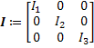: The moment of inertia matrix of the satellite, where , and are the principal moments of inertia.
The constants , and are defined as follows:
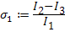, 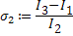,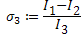
State Variables
The state variables are the satellite’s angular velocity and the quaternion that describes the rotation from the orbit coordinate system to the body coordinate system.
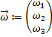, 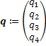
Controller Coefficient [Design Input]
K: the B-dot controller gain, which is greater than 0.

System Model for De-tumbling Mode
The satellite system in de-tumbling mode is described by differential equations of the form
where

So the system equations may be described as:
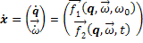 (1)

(Note that there is a difference between and . The is used to denote the time derivative of the vector, represented in the body-fixed coordinate system. On the other hand, represents , which includes the change of the components of the vector due to rotation of the coordinate system as well as the change in the vector itself.)

The definition of comes from the time derivative of a quaternion. The quaternion represents the rotation that would cause the orbit coordinate system to coincide with the body-fixed coordinate system, and hence:

(2)

where is the relative angular velocity of the body-fixed coordinate system w. r. t. the orbit coordinate system, and the function is defined as:

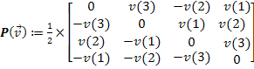
in the above equation is given by:
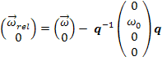
(Note that the product in the above equation follows the rules of quaternion multiplication described in [2], and not matrix multiplication.)

Substituting for in (2), we get:

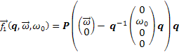 (3)

The definition of comes from Newton’s Second Law for a rotating body.
Newton’s Second Law gives the following equation:
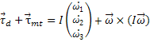

where is the disturbance torque and is the torque due to the magnetorquers.

Rearranging the equation, we get
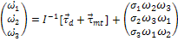 (4)
We know that:
,
where is the control signal composed of the magnetic moment generated by the three magnetorquers, and is Earth’s magnetic field.
According to the B-dot control law, we apply where:
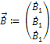

Therefore,
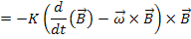
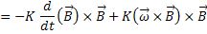
(5)
where the function is the skew-symmetric matrix used to find the cross-product and defined as follows:
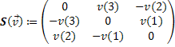
in the above equations is described in the body-fixed coordinate system. Since the components of the magnetic field vector in the orbit coordinate system, , are known as a function of time, we write in terms of this vector by applying a coordinate transformation.
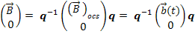
Similarly, can be written as 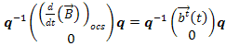
Hence substituting for in (5), we get:
(6)
Expanding all the terms and substituting in (1), we get:
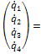
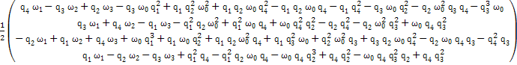
and
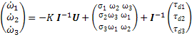,
where U is defined as follows:
U(1)=
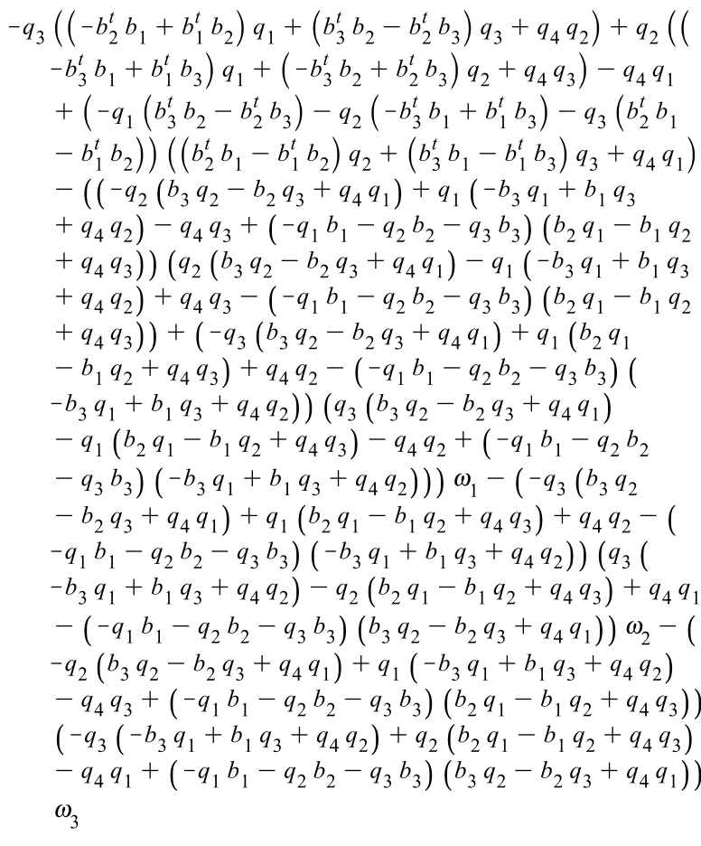

U(2)= 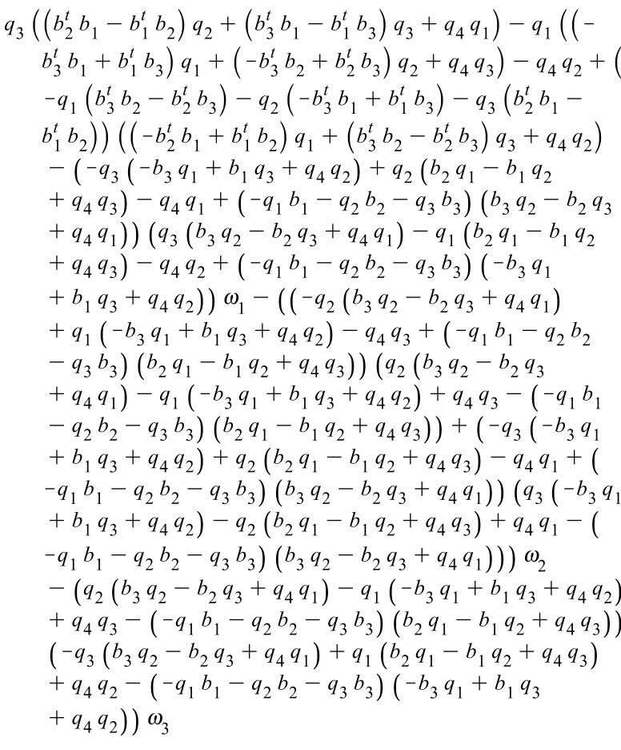

U(3)= 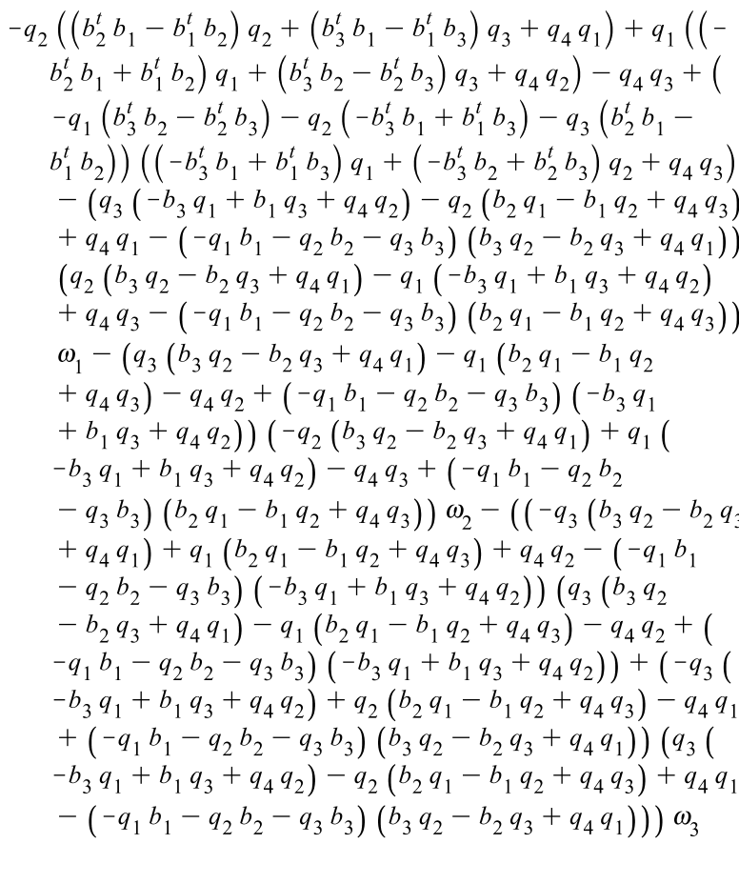

References
- A. C. Stickler and K. T. Alfriend (1974), Elementary Magnetic Control System, Journal of Spacecraft and Rockets, Vol. 13, No. 5, 1975, pp. 282-287.

- Lawrence Fallon (1985), Appendix D: Quaternions, Spacecraft Attitude Determination and Control, edited by James R Wertz, D. Reidel Publishers, pp. 758-759.

Coils of wire through which current is passed to generate a magnetic moment, so that they experience a torque due to the Earth’s magnetic field.
The vector from the centre of the satellite to the centre of the Earth.

